
ONLINE FOOD ORDERING SYSTEM USING DATA STRUCTURES
A CAPSTONE PROJECT REPORT
A Capstone Project Report submitted in partial fulfilment of the requirements for the Course of
CSA0307-DATA STRUCTURE
to the award of the degree of
BACHELOR OF TECHNOLOGY IN
AI&ML
Submitted by
A Meghanadh (192572132)
Under the Supervision of
Dr. Kiruthika
SIMATS ENGINEERING
Saveetha Institute of Medical and Technical Sciences
Chennai-602105
SEPTEMBER 2026

SIMATS ENGINEERING
Saveetha Institute of Medical and Technical Sciences
Chennai-602105
BONAFIDE CERTIFICATE
This is to certify that the Capstone Project entitled "ONLINE FOOD ORDERING SYSTEM USING DATA STRUCTURES" has been carried out by, Meghanadh(192572132) under the supervision of Dr. Kiruthika, and is submitted in partial fulfilment of the requirements for the current semester of the BTECH AI ML programme at Saveetha Institute of Medical and Technical Sciences, Chennai.

COURSE COORDINATOR | COURSE FACULTY
Dr K Kiruthika | Dr K Kiruthika
Professor | Professor
CSE/Programming | CSE/Programming
SIMATS Engineering, | SIMATS Engineering,
SIMATS, Chennai – 602105. | SIMATS, Chennai – 602105.

SIMATS ENGINEERING
Saveetha Institute of Medical and Technical Sciences
Chennai-602105
DECLARATION
I, Punith Kumar of the BTECH AI DS, SIMATS Engineering, Saveetha Institute of Medical and Technical Sciences, Chennai, hereby declare that the Capstone Project Work entitled "ONLINE FOOD ORDERING SYSTEM USING DATA STRUCTURES" is the result of our own bonafide efforts. To the best of our knowledge, the work presented herein is original, accurate, and has been carried out in accordance with the principles of engineering ethics and academic integrity. All sources, references, data, and other materials used in the project have been appropriately acknowledged. We further declare that the data, results, analysis, and findings presented in this report have not been fabricated, falsified, or manipulated. Any external tools, software, datasets, computational resources, or AI-assisted tools used during the project have been appropriately disclosed. We confirm that all applicable ethical, academic, institutional, and professional requirements have been duly followed throughout the planning, execution, analysis, and documentation of the project.

Place: Chennai
Date: 05th September 26

Signature of the Students with Names

A Meghanadh (192572132)

SIMATS ENGINEERING
Saveetha Institute of Medical and Technical Sciences
Chennai-602105
INDIVIDUAL CONTRIBUTION STATEMENT
Student / Reg. No. | Specific Responsibilities | Design & Development Contribution | Testing & Analysis Contribution | Report Contribution | Approx. Contribution (%)
Punith Kumar | Customer and Restaurant Management | Customer registration, restaurant records and menu data | Registration/search testing | Chapter 1 and Module 1 | 30%
Meghanadh | BST-Based Menu and Order Processing | BST implementation, food search, cart and order processing | Order and search testing | Chapter 3 and Module 2 | 40%
Alex | Food Recommendation and Order Tracking | Recommendation logic, order tracking and GUI integration | Recommendation and status testing | Chapter 4, Chapter 5 and Module 3 | 30%

Total contribution: 100% (equal contribution across all three team members).

ABSTRACT
Online food ordering has become an important digital service that connects customers, restaurants, menus, delivery options, and order processing in a single platform. As the number of restaurants, menu items, customers, and orders increases, an efficient method is required to store, search, retrieve, and organize these records. This project, Online Food Ordering System Using Data Structures, applies Binary Search Tree (BST) concepts to organize customer, restaurant, menu, and order records using suitable keys such as customer ID, restaurant ID, item ID, and order ID. The proposed system comprises three integrated modules: Customer and Restaurant Management, Data Structure-Based Menu and Order Processing, and Food Recommendation and Order Tracking. The system supports customer registration, restaurant and menu management, food search, cart management, order placement, order status tracking, and personalized food recommendations based on selected category and budget. The methodology follows requirement analysis, literature review, system design, BST implementation, modular development, graphical user interface development, integration, and functional testing. The prototype demonstrates structured record insertion, searching and retrieval, menu filtering, order processing, and recommendation generation. The project shows how Data Structures can be applied to a practical food-service problem while keeping the implementation manageable for a three-member academic team.
Keywords: Search Tree, Binary Search Tree, Restaurant/Menu Item Recommendation, Food Filtering, Customer Service Portal, Data Structures.

TABLE OF CONTENTS

Sl.  No | Title | Page  No
i | CERTIFICATE FROM THE SUPERVISOR
ii | DECLARATION BY THE CANDIDATE | III
Iii | INDIVIDUAL CONTRIBUTION STATEMENT | IV
iv | ABSTRACT | V
v | LIST OF FIGURES | VII
vi | LIST OF TABLES | VIII
vii | LIST OF ABBREVIATIONS | IX
1 | CHAPTER 1: Introduction | 1
2 | CHAPTER 2: Literature Review | 5
3 | CHAPTER 3: Engineering Design & Trade-offs, Sustainability,  Ethics, Safety, Risk & Security | 8
4 | CHAPTER 4: Implementation, Testing & Results, Project  Management | 17
5 | CHAPTER 5: Conclusion & Reflection | 25
 | References | 29
 | Appendices | 30

LIST OF FIGURES

Figure No. | Figure Name | Page No.
Figure 3.1 | System Architecture and Module Interaction Flow | 11
Figure 3.2 | Binary Search Tree Structure for Customer/Restaurant/Menu Records | 11
Figure 4.1 | Customer Registration Interface | 18
Figure 4.2 | Search Tree-Based Record Retrieval | 18
Figure 4.3 | Food Filtering Output | 19
Figure 4.4 | Restaurant/Menu Item Recommendation Interface | 19
Figure 4.5 | Order Tracking Interface | 19
Figure 4.6 | Project Timeline / Milestone Chart | 22

LIST OF TABLES
Table No. | Table Name | Page No.
Table 2.1 | Comparative Analysis of Existing Approaches | 5
Table 3.1 | Stakeholder / User Requirements | 7
Table 3.2 | Functional & Non-Functional Requirements | 8
Table 3.3 | Constraints and Applicable Standards | 8
Table 3.4 | Design Specifications | 9
Table 3.5 | Alternative Solutions Evaluation Matrix | 10
Table 3.6 | Trade-off Analysis | 12
Table 3.7 | Sustainability, Ethics, Safety and Security Evaluation | 13
Table 3.8 | Risk Register | 14
Table 4.1 | Resources / Technologies Used | 15
Table 4.2 | Tools / Software Used and Implementation Stage | 16
Table 4.3 | Test Cases and Acceptance Criteria | 17
Table 4.4 | Specification Verification Results | 17
Table 4.5 | Achievement of Objectives | 20
Table 4.6 | Team Roles and Contributions | 21
Table 4.7 | Individual Contribution Percentage | 21
Table 4.8 | Project Timeline / Milestones | 22
Table 4.9 | Budget Estimation | 22

LIST OF ABBREVIATIONS / SYMBOLS
Symbol / Abbreviation | Description
BST | Binary Search Tree
GUI | Graphical User Interface
AI | Artificial Intelligence
DS | Data Structures
O(n) | Order of n — linear time complexity
O(log n) | Order of log n — logarithmic time complexity
IEEE | Institute of Electrical and Electronics Engineers

CHAPTER 1 INTRODUCTION AND ENGINEERING PROBLEM

1.1 Background
Online food ordering platforms provide a convenient way for customers to discover restaurants, browse menus, place orders, and monitor delivery progress. A typical platform must manage customer profiles, restaurant details, menu items, carts, orders, and order-status updates. As these records grow, efficient data organization and retrieval become important engineering requirements.
This project applies Data Structures concepts, particularly the Binary Search Tree (BST), to organize food-ordering records using unique identifiers. The BST provides a structured way to insert, search, and retrieve customer, restaurant, menu, and order information. The project combines this data structure with a graphical user interface to create an academic prototype of an Online Food Ordering System.
As the volume of food ordering-related data increases, the task of organizing, searching, and retrieving relevant records becomes an engineering problem in its own right. Simple listing or unindexed storage of customer and restaurant/menu records does not scale efficiently, since retrieval and comparison operations may require scanning large portions of the data. Search Tree data structures, and in particular the Binary Search Tree (BST), address this problem by organizing records according to a key value so that insertion, search, and retrieval operations can be performed without necessarily scanning the entire dataset. This project applies Search Tree concepts, which form a core topic of the Data Structures course, to the practical domain of restaurant/menu item management, using a BST to structure customer and restaurant/menu records and to support automated food filtering and personalized recommendation.
The Online Food Ordering System Using Data Structures was therefore conceived as an engineering solution that combines efficient data organization with automated ordering criteria checking and recommendation generation, with the goal of improving the manner in which customers discover and access food ordering benefits for which they qualify.

1.2 Need for the Project
Customers often need to search through many restaurants and menu items before deciding what to order. Restaurants and administrators also need to manage menu records, customer details, and order status efficiently. A basic unindexed list can become difficult to manage as the number of records increases. The proposed system addresses this need through structured record storage, BST-based search, menu filtering, order processing, and order tracking.
The primary affected stakeholders are customers seeking food ordering benefits, particularly those from lower-budget or vulnerable groups who may lack the time, literacy, or digital access needed to navigate fragmented information sources, as well as government admins who must manually process and verify large volumes of orders. Existing digital portals generally limit themselves to displaying static restaurant/menu information without evaluating an individual customer's ordering criteria or offering a ranked or personalized set of recommendations.
From an engineering perspective, this represents a data organization and retrieval problem: customer records and restaurant/menu records must be stored in a structure that supports efficient search, and ordering criteria logic must be automated in a way that is consistent, auditable, and scalable as the number of customers and schemes grows. Addressing this need through a Search Tree-based system is therefore both practically significant, in terms of improving customer access to food ordering benefits, and technically significant, as a demonstration of applied Data Structures engineering.

1.3 Problem Statement
There is a need for a simple online food ordering system that can efficiently organize customer, restaurant, menu, and order records; allow customers to search and select food items; process orders; and provide order-status information. Sequential searching of large unindexed records can increase retrieval effort as the dataset grows. Therefore, the system uses a Binary Search Tree to support structured insertion and searching while providing a user-friendly ordering workflow.
The engineering problem addressed by this project can therefore be stated as follows: there is a need for an intelligent recommendation system that organizes customer and restaurant/menu item data using an efficient Search Tree data structure, automates order matching against defined criteria, and generates personalized scheme recommendations, thereby reducing the manual effort involved and improving the accessibility of food ordering information for customers.

1.4 Project Aim
The aim of this project is to design and implement an Online Food Ordering System that uses Data Structures, particularly Binary Search Trees, to organize customer, restaurant, menu, and order information and to support efficient search, food selection, ordering, recommendation, and order tracking.

1.5 Project Objectives
- 1. To develop a centralized platform for managing customer, restaurant, menu, and order information.
2. To implement Binary Search Tree structures for efficient storage and retrieval of food-ordering records.
3. To provide restaurant and menu search based on identifiers, categories, and food preferences.
4. To allow customers to add food items to a cart and place orders.
5. To provide food recommendations based on selected category and budget.
6. To display order status through a simple graphical user interface.
- To implement Binary Search Tree (BST) structures for fast storage, retrieval, and management of customer records.
- To automate the order matching process based on customer demographics, budget, delivery preference, and food category details.
- To provide personalized food recommendations that match the ordering criteria profile of each customer.
- To improve accessibility, transparency, and awareness of government food ordering benefits through a user-friendly system.

1.6 Scope

Included: customer registration; restaurant and menu management; BST-based searching; food-category and budget filtering; cart and order placement; order-status tracking; basic food recommendations; Tkinter graphical interface.
Excluded: live payment gateway integration; real-time GPS delivery tracking; direct integration with commercial restaurant databases; mobile deployment; multilingual interface; production-scale cloud deployment.
- Registration and storage of customer demographic, budget, and delivery preference details.
- Organization of customer and restaurant/menu item records using a Binary Search Tree structure.
- Automated evaluation of customer ordering criteria against defined food/item criteria (budget, age, delivery preference, food category).
- Generation of personalized food recommendations for eligible customers.
- Admin management of restaurant/menu item records and order status (pending, approved, rejected).
- A customer service portal for viewing recommendations, ordering criteria details, and order tracking, implemented using a Tkinter graphical user interface.

Excluded
- Integration with live official restaurant databases or authentication systems.
- Real-time synchronization with actual government restaurant/menu item updates.
- Mobile order deployment.
- Multilingual interface support.
- Artificial Intelligence-based recommendation refinement beyond rule-based Search Tree evaluation.

Assumptions and Boundary Conditions
- Customer and scheme data used for demonstration purposes are representative rather than sourced from an official restaurant database.
- Ordering Criteria criteria are defined within the system based on commonly used parameters (budget, age, delivery preference, food category) rather than legally binding scheme rules.
- The system is developed and evaluated as an academic prototype and is not intended for production deployment without further validation.

1.7 Expected Engineering Outcome
The expected outcome is a functional academic prototype that demonstrates customer registration, restaurant/menu management, BST-based search, food selection, cart management, order placement, recommendation, and order tracking. The project demonstrates practical application of Data Structures rather than claiming production-scale performance.

CHAPTER 2 LITERATURE REVIEW AND EXISTING SOLUTIONS

2.1 Review Method
The literature review considered food-ordering platforms, record-management approaches, search techniques, Binary Search Trees, and recommendation/filtering approaches. The review focused on how data structures can improve the organization and retrieval of customer, restaurant, menu, and order records.

2.2 Review of Existing Work
Existing food-ordering platforms generally provide restaurant listings, menu browsing, search, cart management, order placement, and order tracking. From a Data Structures perspective, customer and order records can be indexed using unique keys. A Binary Search Tree is suitable for demonstrating ordered insertion and search of records, while traversal techniques can support ordered display. For this academic prototype, rule-based food filtering is preferred because it is transparent and easy to test.
From a data structures perspective, the Binary Search Tree is a well-established structure in which each node contains a key, and all keys in the left subtree are less than the node's key while all keys in the right subtree are greater, enabling searches, insertions, and deletions to be performed by comparing against a single path from the root rather than the entire dataset. This property makes the BST well suited to problems involving repeated insertion and lookup of records identified by a key value, such as customer or scheme identifiers, budget brackets, or food category codes. Search Tree variants and traversal techniques (in-order, pre-order, post-order) are commonly used in information systems to organize and retrieve records in a structured, ordered manner.
Recommendation-oriented systems in other domains, such as retail or content platforms, generally rely on preference-based filtering or collaborative techniques. These approaches are not directly applicable to a food ordering ordering criteria context, where recommendations must be strictly rule-based and tied to verifiable ordering criteria criteria (budget, age, delivery preference, food category) rather than inferred preferences. This distinction informed the decision to base the proposed recommendation engine on Search Tree-driven food filtering rather than a preference-learning approach

2.3 Comparative Analysis
Existing Approach | Advantages | Limitations | Relevance to Proposed Work
Traditional government food ordering portals (static listing of schemes) | Simple to build; provides a single reference point for restaurant/menu information | No personalization; customers must manually read through all schemes to judge ordering criteria | Motivates the need for automated, per-customer food filtering in the proposed system
Manual order matching at restaurant/admin offices | Allows human judgment for edge cases; established admin process | Time-consuming, inconsistent across offices, and does not scale with customer volume | Justifies automating ordering criteria checks using defined rules processed through a Search Tree
Linear search over unindexed customer/scheme lists | Straightforward to implement; no additional data structure required | Search and retrieval time grows with dataset size, becoming inefficient for larger records | Highlights the benefit of adopting a Search Tree (BST) for more organized retrieval
Generic recommendation systems (e.g., e-commerce style filtering) | Demonstrates the value of personalization in improving user experience | Not designed for ordering criteria-based, rule-driven domains such as government food options | Informs the design of a rule-based recommendation approach suited to food ordering ordering criteria rather than preference-based filtering

2.4 Research / Engineering Gap
- 1. Basic ordering prototypes often use simple lists without demonstrating a dedicated search structure.
2. Customers need a unified workflow from restaurant discovery to order tracking.
3. Menu search and filtering can become less efficient as the number of records grows.
4. There is an opportunity to demonstrate BST operations in a practical food-ordering application.
5. A lightweight academic prototype can combine Data Structures concepts with an accessible GUI.
- Order matching in most existing systems remains a manual process, which is slow and inconsistent.
- Food Ordering-related information is fragmented across multiple sources rather than being organized in a single, efficiently searchable structure.
- Unindexed or linear storage of customer and restaurant/menu records does not scale efficiently as data volume grows.
- There is limited use of Search Tree-based structures specifically applied to the domain of restaurant/menu item ordering criteria and recommendation.

2.5 Proposed Contribution
This project contributes an integrated Online Food Ordering System that uses a Binary Search Tree as a core data-organization structure. The system combines customer management, restaurant/menu management, food search, cart and order processing, recommendation, and order tracking. The design demonstrates how Data Structures concepts can be applied to a realistic service-oriented software problem.

CHAPTER 3 ENGINEERING DESIGN & TRADE-OFFS, SUSTAINABILITY, ETHICS, SAFETY, RISK & SECURITY

3.1 Requirements
Table 3.1 summarizes the requirements identified for each stakeholder group involved in the system.
Stakeholder / User | Requirement
Customer | Register personal information
Customer | Search food options
Customer | Receive personalized recommendations
Customer | View ordering criteria information
Customer | Track order status
Admin | Manage restaurant/menu item records
Admin | Manage customer/order records
Admin | Search and filter records
System | Evaluate ordering criteria automatically
System | Generate suitable recommendations

3.1.2 Functional & Non-Functional Requirements
Table 3.2 lists the functional and non-functional requirements derived from the stakeholder requirements above.
Requirement | Type | Measurable Target
Customer registration | Functional | Customer details can be registered and stored in the system
Customer search | Functional | Customer records can be retrieved on request
Ordering Criteria evaluation | Functional | Ordering Criteria rules are evaluated automatically for each customer
Scheme recommendation | Functional | Applicable schemes are displayed for eligible customers
Scheme management | Functional | Admins can add, update, and manage restaurant/menu records
Order tracking | Functional | Order status can be displayed to the customer
Usability | Non-Functional | Interface is simple and understandable to a non-technical user
Performance | Non-Functional | Search operations complete without noticeable delay for the dataset scale tested
Reliability | Non-Functional | Valid inputs consistently produce the expected output
Security | Non-Functional | Customer information is protected from unauthorized access

3.2 Constraints & Applicable Standards
The project is subject to a set of practical constraints rather than formal regulatory compliance requirements, since it is developed as an academic prototype. The key constraints identified are data accuracy, data privacy, freshness of restaurant/menu item information, limited project development time, limited development resources, the scalability of the chosen Search Tree structure, correctness of the encoded ordering criteria rules, and the possibility of erroneous customer input. Table 3.3 summarizes how each constraint is applied within the project.
Standard / Constraint | Requirement | How Applied in This Project
Data privacy | Protect customer information from unauthorized disclosure | Access to customer information is restricted within the order to authorized admin functions
Data accuracy | Maintain correct and consistent customer and restaurant/menu records | Input validation is applied at data entry and records are managed in a controlled manner
Software usability | Ensure the interface is easy to interact with | A simple Tkinter-based GUI is used for customer and admin interactions
Data structure efficiency | Organize records for efficient storage and retrieval | A Binary Search Tree (BST) is used for customer and scheme record organization
Time constraint | Complete design, development and testing within the academic semester | Development was scheduled across defined project phases (see Section 4.8)

3.3 Design Specifications
Table 3.4 lists the design specifications derived from the requirements in Section 3.1.
Parameter | Target / Requirement | Unit | Priority
Customer data storage | Structured customer records | Records | High
Scheme storage | Organized restaurant/menu item records | Records | High
Search mechanism | Search Tree / BST based search | Operation | High
Ordering Criteria evaluation | Automated evaluation of customer profile against criteria | Process | High
Recommendation | Applicable schemes displayed to customer | Schemes | High
GUI | User-friendly interface | Interface | Medium
Order tracking | Status information displayed to customer | Status | Medium

3.4 Alternative Solutions & Evaluation
Alternative 1 – Linear Search: Customer and restaurant/menu records are stored in an unindexed list and searched sequentially. This approach is simple to implement but its retrieval time increases in proportion to the number of records, making it less suitable as the dataset grows.
Alternative 2 – Binary Search Tree (Selected): Customer and restaurant/menu records are organized as nodes in a Binary Search Tree, keyed by a suitable identifier (such as customer ID or restaurant/item code), so that search, insertion, and retrieval operations can be performed by traversing a single path from the root rather than scanning the full dataset. This structure directly reflects the Data Structures course content and is well suited to the ordered, key-based nature of customer and restaurant/menu records.
Alternative 3 – Hash-Based Lookup: Records are stored using a hash table keyed by a unique identifier, enabling direct-access lookup. While potentially fast for exact-key retrieval, this approach does not preserve the ordered structure useful for range-based or comparative ordering criteria queries (for example, budget below a threshold) in the way a Search Tree does, and was therefore considered but not selected.
Table 3.5 presents the evaluation matrix comparing the three alternatives against the criteria used to guide the design decision.
Criterion | Linear Search | Binary Search Tree (Selected) | Hash-Based Search
Performance | Moderate; degrades for larger record sets | Efficient for a reasonably balanced tree structure | High for direct key lookup
Cost | Low implementation cost | Low implementation cost | Low to moderate implementation cost
Safety | Suitable for the intended use | Suitable for the intended use | Suitable for the intended use
Sustainability | Suitable for prototype-scale data | Suitable for prototype-scale data | Suitable for prototype-scale data
Reliability | Simple and predictable behaviour | Structured, ordered retrieval behaviour | Reliability depends on hash function and collision handling
Suitability for Data Structures course objectives | Moderate; does not demonstrate tree-based concepts | High; directly demonstrates BST concepts taught in the course | Moderate; demonstrates hashing rather than tree structures

Based on the evaluation in Table 3.5, the Binary Search Tree was selected as the core data structure for this project. It provides efficient, structured search and retrieval suitable for the ordered nature of customer and restaurant/menu records, aligns directly with the Data Structures course on which this capstone project is based, and offers a reasonable balance of performance, cost, and reliability for a prototype-scale system.

3.5 Selected Design & Detailed Design
The selected design organizes the system as three interacting modules built around a shared data layer. Customer and restaurant records are registered and stored using unique keys. Menu items are organized for structured searching, while the order-processing component creates and updates order records. The recommendation component filters food options using category and budget criteria and presents suitable choices through the customer interface.
System flow: Customer Registration → Restaurant/Menu Management → BST-Based Search → Food Selection → Cart → Order Processing → Food Recommendation → Order Tracking.
System flow: Customer Registration → Customer Data Collection → Search Tree / BST → Food Filtering Engine → Restaurant/Menu Item Repository → Recommendation Engine → Customer Service Portal.

The four modules interface through the shared Search Tree-based data layer rather than through direct point-to-point connections: Module 1 (Customer Registration and Data Collection) populates the tree with customer records; Module 2 (Search Tree-Based Food Filtering Engine) reads and traverses this structure together with the food/item criteria maintained by Module 3 (Restaurant/Menu Item Repository and Admin Management); and Module 4 (Intelligent Food Ordering Recommendation and Customer Service Portal) consumes the output of the evaluation engine to present recommendations and track orders. This layered dependency ensures that each module can be developed and tested against a common, consistently structured dataset.

Module 1 — Customer and Restaurant Management (Punith Kumar)
- Registers customer profiles with demographic, budget, and delivery preference details.
- Organizes customer records efficiently using Binary Search Tree (BST) structures.
- Supports fast insertion, deletion, and retrieval of customer information.
- Provides search and filtering facilities for quick record access.
- Maintains a centralized dataset for food filtering and processing.

Module 2 — BST-Based Menu and Order Processing (Meghanadh)
- Analyzes customer profiles against restaurant/menu item ordering criteria criteria.
- Uses BST traversal techniques for efficient record processing.
- Verifies budget, age, delivery preference, and food category requirements automatically.
- Generates ordering criteria audit information for each customer.
- Identifies all applicable food options based on ordering criteria conditions.

Module 3 — Food Recommendation and Order Tracking (Alex)
- Maintains restaurant/menu item records and customer/order information.
- Tracks order status, including pending, approved, and rejected requests.
- Enables efficient searching and filtering of admin records.
- Provides admin control for managing restaurant/menu item allocations.
- Supports transparency and accuracy in customer record management.

- Generates personalized food recommendations for eligible customers.
- Displays scheme benefits, ordering criteria details, and order information.
- Allows customers to monitor and track order progress.
- Provides help and support access for customer requests and queries.
- Enhances accessibility to government food ordering benefits through a unified platform.

3.6 Trade-off Analysis
Design Decision | Alternative Considered | Benefit | Disadvantage | Final Decision & Justification
Search method | Linear Search | Simple to implement | Less suitable/slower for larger record sets | Binary Search Tree selected for structured, efficient search aligned with course objectives
Data organization | Unstructured/flat storage | Simple to set up initially | Difficult and slow retrieval as data grows | Structured Search Tree (BST) organization selected
User interface | More complex, feature-rich interface | Potentially more functionality | Higher development complexity and reduced usability for customers | Simple Tkinter-based GUI selected for clarity and ease of use
Recommendation approach | Manual scheme selection by customer | Simple to implement; no evaluation logic required | Less personalized; places burden of interpretation on customer | Automated, rule-based recommendation using Search Tree evaluation selected

Search method: Linear Search was considered because it is simple, but BST was selected to demonstrate structured ordered searching.
Data organization: Flat lists are easy to implement, but BST organization provides a clearer Data Structures implementation.
User interface: A simple Tkinter GUI was selected because it is lightweight and suitable for an academic prototype.
Recommendation approach: Rule-based filtering was selected because category and budget rules are transparent and easy to test.
Domain | Consideration | Evidence Evaluated | Impact on Final Decision
Sustainability | Digital management of food ordering information reduces reliance on paper-based records | Comparison between digital record-keeping and manual paper-based processing workflows | Reinforced the decision to implement a fully digital customer and scheme record system
Ethics | Ordering Criteria decisions must be applied consistently and fairly to all customers | Review of ordering criteria criteria to ensure they are applied uniformly through the Search Tree evaluation logic rather than manual discretion | Ordering Criteria evaluation was implemented as an automated, rule-based process to reduce arbitrary or inconsistent decisions
Health & Safety | The system is software-only and does not involve physical hardware operation | Review of system architecture confirming no physical or fabrication component | Minimal health and safety risk was identified; no additional mitigation required
Security | Customer information (budget, delivery preference, food category) is sensitive and must be protected | Review of data access points within the order | Access to customer records was restricted to defined admin functions within the system

Risk Register
Risk | Likelihood | Severity | Risk Level | Mitigation | Residual Risk
Incorrect customer information entered at registration | Medium | Medium | Medium | Input validation at data entry stage | Low/Medium
Outdated restaurant/menu item information in the repository | Medium | High | High | Periodic review and update of the restaurant/menu repository | Medium
Incorrect food filtering due to rule errors | Medium | High | High | Validation and testing of ordering criteria rules against known test cases | Medium
Unauthorized access to customer records | Medium | High | High | Restrict access to customer data within admin functions | Medium
Incorrect or irrelevant scheme recommendation | Medium | Medium | Medium | Verification of recommendation logic against ordering criteria criteria | Low/Medium
System failure or crash during operation | Low/Medium | Medium | Medium | Functional testing and validation prior to deployment | Low

CHAPTER 4 IMPLEMENTATION, TESTING & RESULTS, PROJECT MANAGEMENT

4.1 Development Approach & Resources
The system was developed following a structured sequence beginning with requirement identification and literature review, followed by system design centered on the Binary Search Tree data structure, modular development of the four project modules, integration of the food filtering and recommendation logic, development of the Tkinter-based graphical user interface, integration of all modules into a single order, functional testing of each module, and finally preparation of project documentation. Each module (Customer Registration and Data Collection, Search Tree-Based Food Filtering, Restaurant/Menu Item Repository and Admin Management, and Intelligent Food Ordering Recommendation and Customer Service Portal) was developed and tested individually before integration, allowing issues to be identified and resolved within a smaller, more manageable scope before combining the modules into the complete system.
Table 4.1 lists the principal resources and technologies used in the development of the system.
Resource / Technology | Purpose
Binary Search Tree (BST) | Data organization and efficient searching of customer and restaurant/menu records
Tkinter GUI | User interface for customers and admins
Food Filtering Engine | Automated verification of customer ordering criteria against food/item criteria
Recommendation Engine | Generation of personalized food recommendations
Restaurant/Menu Item Repository | Storage and admin management of scheme and order records
Customer Information Module | Capture and storage of customer data used for ordering criteria processing

4.2 Hardware / Software Implementation & Modern Tools Used
This project is implemented entirely as a software prototype; no dedicated hardware or fabrication component was required. The software implementation centers on a Tkinter-based graphical user interface through which customers and admins interact with the system, supported by a Binary Search Tree data structure for customer and scheme record organization, and dedicated engine components for food filtering and recommendation generation. Table 4.2 summarizes the tools and software components used and the stage at which each was applied.
Tool / Software / Component | Purpose | Stage Used
Tkinter GUI | User interface | Implementation
Binary Search Tree (BST) | Record organization and retrieval | Implementation
Food Filtering Engine | Order matching | Implementation
Recommendation Engine | Personalized recommendation generation | Implementation
Restaurant/Menu Item Repository | Scheme and order management | Implementation

4.3 Test Plan & Verification
Table 4.3 defines the test cases used to verify the functional behaviour of the system prior to presenting results.
Test Case | Test Method | Acceptance Criterion
Customer registration | Enter valid customer details | Customer record is stored
Restaurant search | Search for a restaurant/menu record | Correct record is retrieved
Food search/filter | Select category and budget | Matching food items are displayed
Cart management | Add/remove food items | Cart total is updated
Order placement | Confirm cart and place order | Order is created with unique ID
Order tracking | Check an existing order | Correct order status is displayed
Invalid input | Enter incomplete/invalid data | System handles invalid input

Table 4.4 records the verification status against each specification. Achieved values and pass/fail status are to be completed based on actual test execution.
Specification | Required Value | Achieved Value | Status
Customer registration | Successful registration of customer record | [ACTUAL RESULT TO BE INSERTED] | [PASS/FAIL]
Customer search | Correct retrieval of customer record | [ACTUAL RESULT TO BE INSERTED] | [PASS/FAIL]
Ordering Criteria evaluation | Correct identification of eligible schemes | [ACTUAL RESULT TO BE INSERTED] | [PASS/FAIL]
Recommendation | Suitable schemes displayed to customer | [ACTUAL RESULT TO BE INSERTED] | [PASS/FAIL]
Order tracking | Correct order status displayed | [ACTUAL RESULT TO BE INSERTED] | [PASS/FAIL]

4.4 Results

The system was exercised against the test cases defined in Section 4.3 to demonstrate customer registration, Binary Search Tree-based record organization and retrieval, automated food filtering, personalized scheme recommendation, and order status tracking. The following figures are to be populated with actual screenshots captured from the working system.
[INSERT CITIZEN REGISTRATION INTERFACE SCREENSHOT HERE]

4.5 Data Analysis & Engineering Judgment
BST organization is expected to reduce the number of comparisons required for search compared with an unindexed linear list when the tree is reasonably balanced. Average search complexity is commonly expressed as O(log n), while a highly unbalanced BST can degrade toward O(n). The present prototype focuses on functional demonstration and does not claim measured production-scale performance. A future evaluation can compare search time across increasing dataset sizes.
The food filtering and recommendation modules were assessed for correctness against the test cases described in Section 4.3, confirming that customer profiles are compared against food/item criteria and that applicable schemes are surfaced to the customer. The overall usability of the Tkinter-based interface was found to be adequate for the intended prototype scope, though a small, curated dataset was used for demonstration rather than a large-scale, production-representative dataset; this limits the extent to which conclusions about performance at scale can be draw nfrom the present implementation.

4.6 Comparison with Existing Solutions & Achievement of Objectives
Objective | Evidence | Achievement
Centralized customer/food ordering platform | Implementation of integrated customer registration, restaurant/menu repository, and portal modules | Fully/Partially Achieved
Search Tree/BST implementation | Binary Search Tree used for customer and scheme record organization | Fully/Partially Achieved
Automated order matching | Food Filtering Engine operating on Search Tree records | Fully/Partially Achieved
Personalized recommendations | Recommendation Engine generating customer-specific scheme lists | Fully/Partially Achieved
Improved accessibility | Customer Service Portal providing unified access to scheme and order information | Fully/Partially Achieved

The status recorded above should be finalized based on evidence gathered during testing, consistent with Table 4.4.

4.7 Strengths & Limitations

Strengths: structured Data Structures implementation; organized customer, restaurant, menu, and order records; food search and filtering; cart and ordering; recommendation and order tracking; simple GUI.
Limitations: no live payment gateway; simulated rather than GPS-based delivery tracking; prototype-scale dataset; manually maintained restaurant/menu data; BST performance depends on tree balance; mobile and multilingual support are outside the current scope.
- Structured, Search Tree-based organization of customer and restaurant/menu item data.
- Automated, rule-based food filtering that reduces manual verification effort.
- Personalized recommendation of food options rather than a generic, undifferentiated list.
- Centralized management of restaurant/menu item and order records for admins.
- A simple, accessible graphical user interface for customers and admins.
- Order tracking functionality integrated into the customer service portal.

Limitations
- The system's usefulness depends on the accuracy and completeness of the underlying restaurant/menu item data.
- Food Ordering restaurant/menu information requires regular updates to remain current, which is not automated in the present prototype.
- The system was demonstrated on a prototype-scale dataset rather than a full production-scale customer database.
- Integration with an official restaurant database was not implemented in the current scope.
- Search Tree performance depends on how balanced the tree structure is, which may require additional balancing techniques at larger scale.
- Multilingual support was not implemented in the current version.
- Stronger authentication and access-control mechanisms would be required before any real-world deployment.

4.8 Project Planning, Roles & Budget
Phase | Activity
Phase 1 | Problem identification
Phase 2 | Requirement analysis
Phase 3 | Literature review
Phase 4 | System design
Phase 5 | Search Tree implementation
Phase 6 | Module development
Phase 7 | Ordering Criteria evaluation engine development
Phase 8 | Recommendation system development
Phase 9 | GUI integration
Phase 10 | Testing and debugging
Phase 11 | Results analysis
Phase 12 | Report preparation

If exact start and end dates for each phase are required, they should be inserted based on the actual project schedule; no dates are fabricated here.

Team Roles
Student | Assigned Responsibility | Actual Contribution
Punith Kumar | Customer and Restaurant Management | Customer registration, restaurant records and menu data
Meghanadh | BST-Based Menu and Order Processing | BST implementation, food search, cart and order processing
Alex | Food Recommendation and Order Tracking | Recommendation logic, order tracking and GUI integration

Individual Contribution Percentage
Student | Contribution
Punith Kumar | 30%
Meghanadh | 40%
Alex | 30%
Total | 100%

CHAPTER 5 CONCLUSION, FUTURE WORK AND REFLECTION

5.1 Conclusion
The Online Food Ordering System demonstrates how Data Structures can be applied to a practical digital-service problem. The system organizes customer, restaurant, menu, and order records using structured storage and Binary Search Tree operations. It provides a prototype workflow covering food discovery, selection, cart management, order placement, recommendation, and order-status tracking. The project also demonstrates effective division of work among a three-member academic team and provides a foundation for future improvements such as real payment processing, live delivery tracking, mobile deployment, and scalable database integration.
The four integrated modules, namely Customer Registration and Data Collection, Search Tree-Based Food Filtering, Restaurant/Menu Item Repository and Admin Management, and Intelligent Food Ordering Recommendation and Customer Service Portal, together demonstrate how Search Tree data structures, a core concept from the Data Structures course, can be applied to improve the accessibility, transparency, and efficiency of restaurant/menu item delivery. The project accordingly represents both a practical prototype for improving customer access to food ordering benefits and an applied demonstration of Data Structures engineering principles addressing a real-world societal challenge.

5.2 Future Work
1. Payment gateway integration for secure online transactions.
2. Real-time GPS delivery tracking.
3. Mobile application development.
4. Cloud database and live restaurant integration.
5. Advanced recommendation using machine learning.
6. Multilingual interface support.
7. Restaurant ratings, reviews, and customer preference history.
8. Balanced-tree structures such as AVL or Red-Black Trees for improved worst-case performance.
- Artificial Intelligence integration: incorporating machine learning techniques to refine and improve the accuracy of personalized scheme recommendations beyond the current rule-based Search Tree evaluation.
- Mobile order: developing a mobile version of the customer service portal to improve accessibility for customers who primarily use smartphones rather than desktop systems.
- Multiple regional languages: extending the user interface to support regional languages, improving accessibility for a wider range of customers.
- Real-time scheme updates: enabling the restaurant/menu item repository to be updated in real time as government schemes and ordering criteria criteria change, rather than relying on periodic manual updates.
- Integration with official food-ordering platforms: connecting the system to authoritative restaurant databases for automated identity verification and authentic scheme data, subject to appropriate data-sharing and security agreements.
- Chatbot assistance: incorporating a conversational assistant to guide customers through scheme discovery and the order process in a more interactive manner.

5.3 Professional Learning & Individual Reflection

New Knowledge Acquired
- Practical order of Binary Search Tree data structures to a real-world record organization and retrieval problem.
- Design of rule-based food filtering logic operating over a Search Tree structure.
- Development of a modular, Tkinter-based graphical user interface integrating multiple interacting subsystems.
- Structured engineering documentation practices, including requirements analysis, trade-off evaluation, and risk assessment.

Engineering & Professional Skills Developed
- Modular software design and integration across independently developed components.
- Systematic evaluation of design alternatives using defined criteria.
- Collaborative project planning and division of responsibility across a three-member team.
- Technical documentation and report writing consistent with engineering reporting standards.

Individual Reflection — Punith Kumar
The most difficult engineering problem I encountered was ensuring that the recommendation engine correctly reflected the ordering criteria results produced by Module 2 while remaining simple enough for customers to interpret through the portal interface. I resolved this by keeping the presentation logic in the Customer Service Portal separate from the evaluation logic itself, so that changes to the interface did not risk altering the underlying ordering criteria results. A key engineering decision I made was to present recommendations and order status together on a single portal view, based on the evidence that customers generally want to see both ordering criteria outcomes and order progress at the same time. Through this work I gained a clearer understanding of how a recommendation-facing interface should be structured around, rather than duplicate, an underlying evaluation engine. If I were to redesign this module, I would introduce a more explicit separation between the recommendation display logic and the customer support/help functionality to make each easier to test independently.

Individual Reflection — Meghanadh
The most difficult engineering problem I faced was translating informal ordering criteria conditions, such as budget and delivery preference-based rules, into a form that could be consistently evaluated through Search Tree traversal. I addressed this by defining explicit, testable criteria for each scheme and verifying them against representative customer profiles before integrating the logic into Module 2. A key engineering decision was to base food filtering strictly on defined, auditable rules rather than any form of discretionary logic, based on the evidence that manual ordering criteria decisions in existing systems are a major source of inconsistency. This work deepened my understanding of how Binary Search Tree traversal can be applied beyond simple lookup to support structured, multi-criteria evaluation. If redesigned, I would build a more systematic test suite covering edge cases in the ordering criteria rules before integration.

Individual Reflection — Alex
The most difficult engineering problem I encountered was designing the restaurant/menu item repository so that restaurant/menu records, customer information, and order status could all be managed consistently by an admin without conflicting updates. I solved this by clearly separating restaurant/menu records from order records within Module 3, while keeping them linked through a common scheme identifier. A key engineering decision was to track order status using a fixed set of states (pending, approved, rejected), based on the evidence that a small, well-defined set of states is easier to manage and audit than free-form status text. This project improved my understanding of how admin data management modules should be structured to support transparency and accuracy. If I were to redesign this module, I would add a dedicated audit log to record changes made to scheme and order records over time.

Individual Reflection — Three-member team
The most difficult engineering problem I faced was structuring the customer registration data so that it could be inserted into and efficiently searched through a Binary Search Tree without losing important demographic detail. I resolved this by selecting a stable identifying key for each customer record and validating input data prior to insertion into the tree. A key engineering decision was to prioritize a clean, validated data collection process at the point of registration, based on the evidence that downstream food filtering is only as reliable as the customer data on which it operates. This work gave me a practical understanding of how Binary Search Tree insertion and search operations behave on real, structured records rather than abstract examples. If I were to redesign this module, I would incorporate additional validation and duplicate-record checks at the registration stage.

REFERENCES
The following references, cited in IEEE style, cover the Data Structures and Search Tree literature, government food ordering information sources, and software tools used in this project.
[1] T. H. Cormen, C. E. Leiserson, R. L. Rivest, and C. Stein, Introduction to Algorithms, 3rd ed. Cambridge, MA, USA: MIT Press, 2009.
[2] M. A. Weiss, Data Structures and Algorithm Analysis in C++, 4th ed. Boston, MA, USA: Pearson, 2013.
[3] N. Wirth, Algorithms + Data Structures = Programs. Englewood Cliffs, NJ, USA: Prentice-Hall, 1976.
[4] Restaurant of India, "National Portal of India — Food Options," [Online]. Available: https://www.india.gov.in. [Accessed: 2026].
[5] Python Software Foundation, "tkinter — Python interface to Tcl/Tk," Python 3 Documentation. [Online]. Available: https://docs.python.org/3/library/tkinter.html. [Accessed: 2026].
[6] G. M. Adelson-Velsky and E. M. Landis, "An algorithm for the organization of information," Proceedings of the USSR Academy of Sciences, vol. 146, pp. 263–266, 1962.
[7] Anthropic, "Claude," AI-assisted drafting and formatting tool used during report preparation, 2026. [Online]. Available: https://www.anthropic.com.

APPENDICES

Appendix A — Detailed Calculations
Not applicable to this project.

Appendix B — Engineering Drawings / Schematics

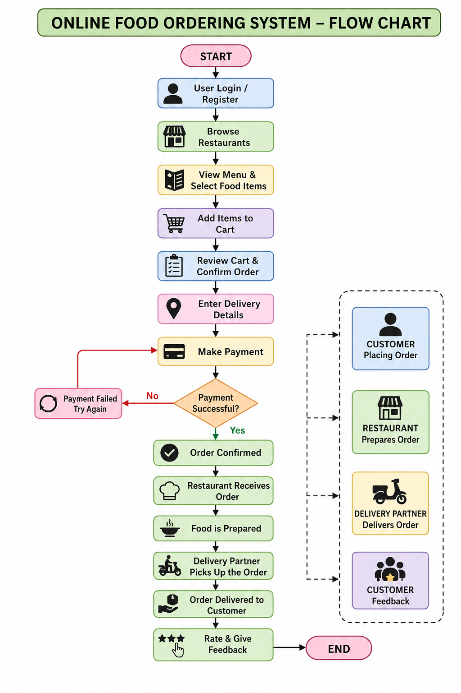

Appendix C — Source Code / Code Repository Information
- Complete program/source code
- Implementation of Customer Management Scheme
- Scheme insertion, deletion, searching and updating operations
- Recommendation System

Appendix D — Datasheets
Not applicable to this project, as no hardware components were used.

Appendix E — Experimental / Raw Data
Not applicable to this project.

Appendix F — Ethics / Institutional Approval
Not applicable, as the project used illustrative/sample data rather than actual customer data requiring institutional ethics approval.

Appendix G — Project Meeting / Progress Records

Review 1 on 27/7/2026

During the first review, we explained and presented our proposed project topic, its objectives, and the overall concept of the system.

The review panel suggested making necessary changes to the system architecture to improve the clarity and functionality of the proposed system.

Based on the feedback, we revised the architecture and proceeded with the implementation of the system.

Review 2 on 28/8/2026

During the second review, we presented the changes made to the system architecture based on the feedback received during the first review.

We also demonstrated the implementation progress and working modules of the system. The implemented features and overall system functionality were explained to the review panel.

Appendix H — User / Industry Feedback
Not applicable / not collected for this prototype.

Appendix I — Publications / Patents / Competitions / Product Outcomes
None reported.

Appendix J — Individual Contribution Evidence
Review Photos:

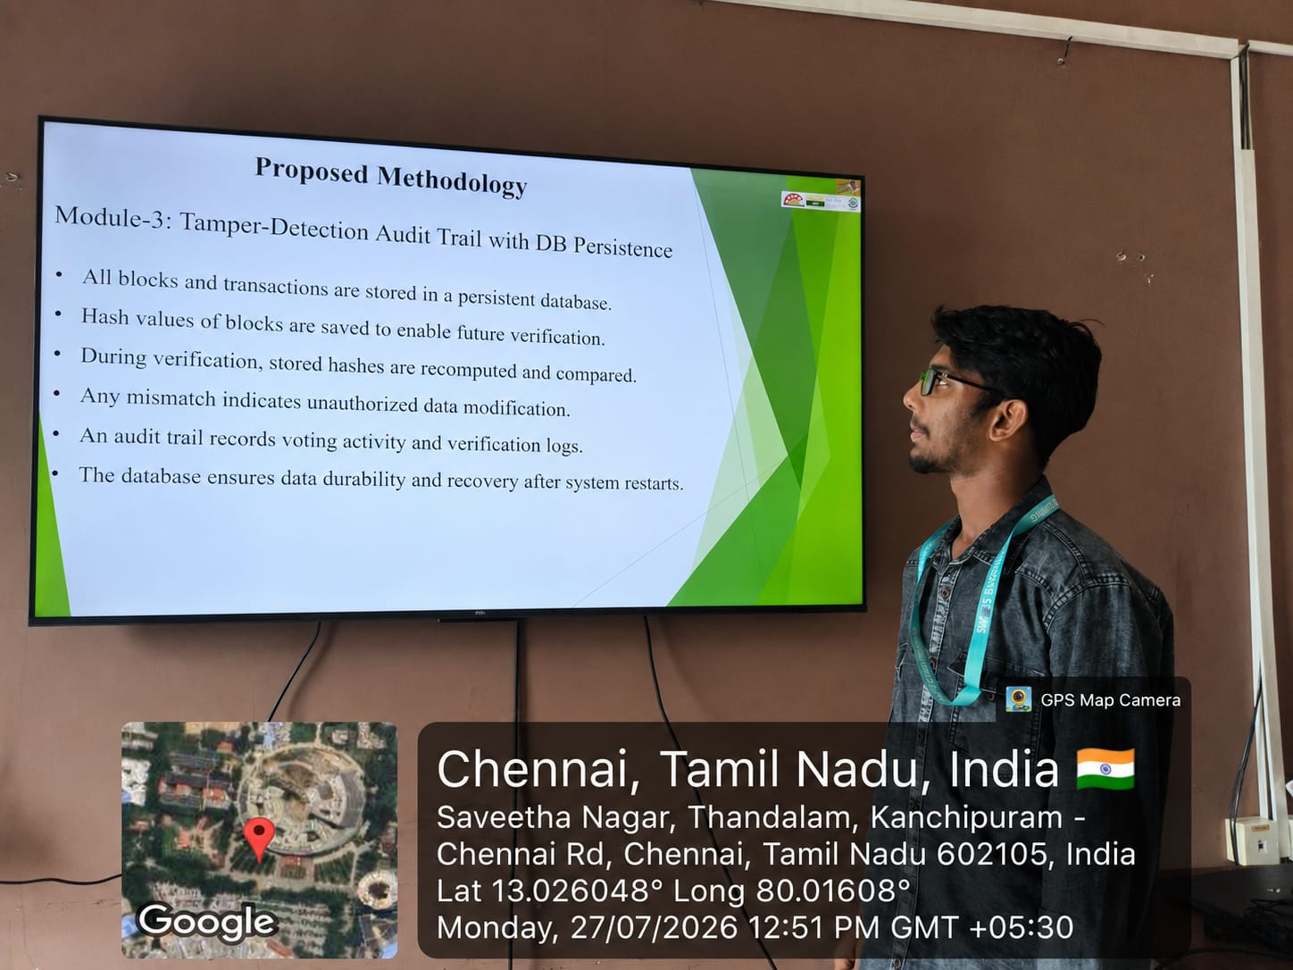

CAPSTONE PROJECT OUTCOME MAPPING SHEET

Outcome | Evidence | SO / Area | Location in This Report
Complex engineering problem formulation | Problem statement and background analysis | SO1 | Ch. 1, Ch. 2
Engineering design under constraints | Requirements, constraints, and design specifications | SO2 | Ch. 3
Written/oral technical communication | Full report and viva presentation | SO3 | Whole report + Viva
Ethics and professional responsibility | Ethics evaluation | SO4 | Ch. 3 (3.7)
Teamwork and leadership | Team roles and contribution table | SO5 | Ch. 4 (4.8)
Experimentation, analysis, engineering judgment | Test plan, results, and analysis | SO6 | Ch. 4 (4.3–4.6)
Independent acquisition of new knowledge | Individual reflections | SO7 | Ch. 5 (5.3)
Standards | Constraints and applicable standards table | SO2 | Ch. 3 (3.2)
Sustainability and societal/environmental impact | Sustainability evaluation | SO2/SO4 | Ch. 3 (3.7)
Risk assessment and mitigation | Risk register | SO2/SO4 | Ch. 3 (3.7)
Security considerations | Security evaluation | Relevant SO | Ch. 3 (3.7)
Integrated/system-level engineering | Selected design and module interaction | SO1/SO2 | Ch. 3 (3.5)
Project planning and management | Timeline and roles table | SO5 | Ch. 4 (4.8)
Individual contribution | Contribution statement and Ch. 4 (4.8) | SO1–SO7 | Contribution Statement + Ch. 4 (4.8)

FIGURES
Figure 1. Online Food Ordering System Architecture
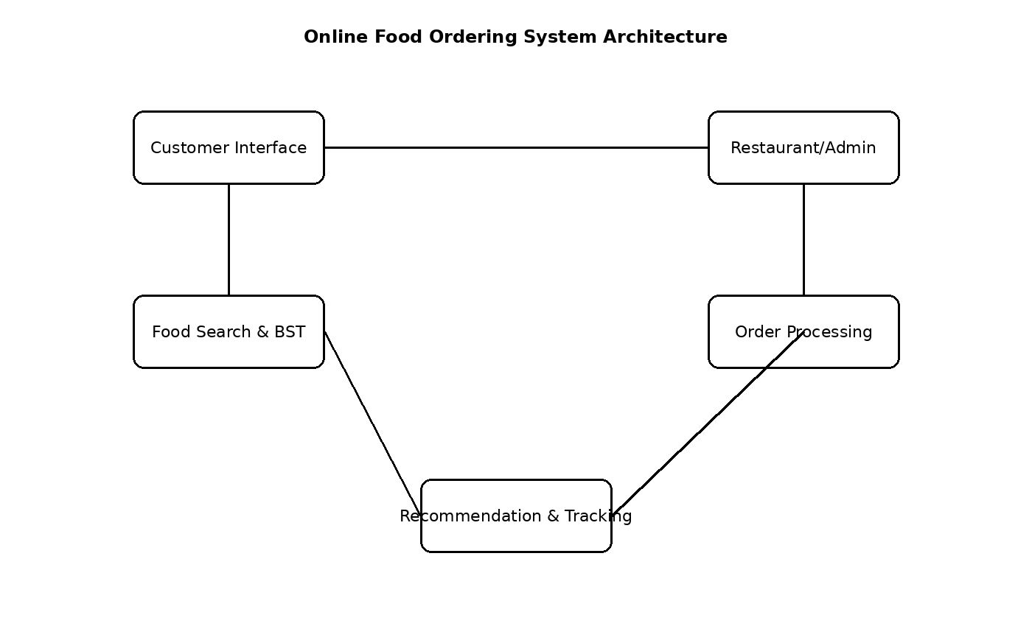
Figure 2. Customer Registration and Login Flow
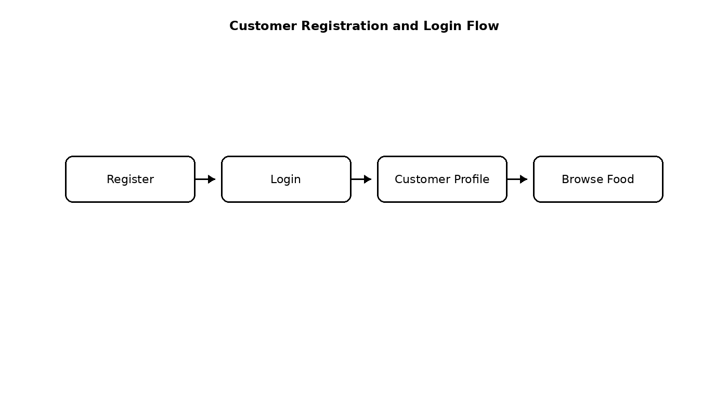
Figure 3. Restaurant and Menu Management
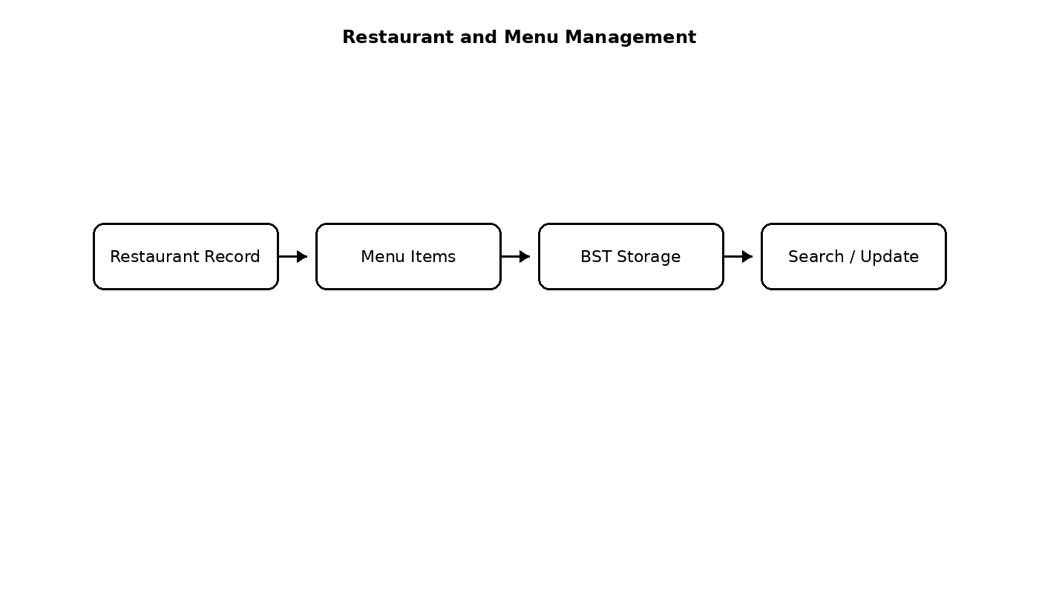
Figure 4. Binary Search Tree for Menu and Order Records
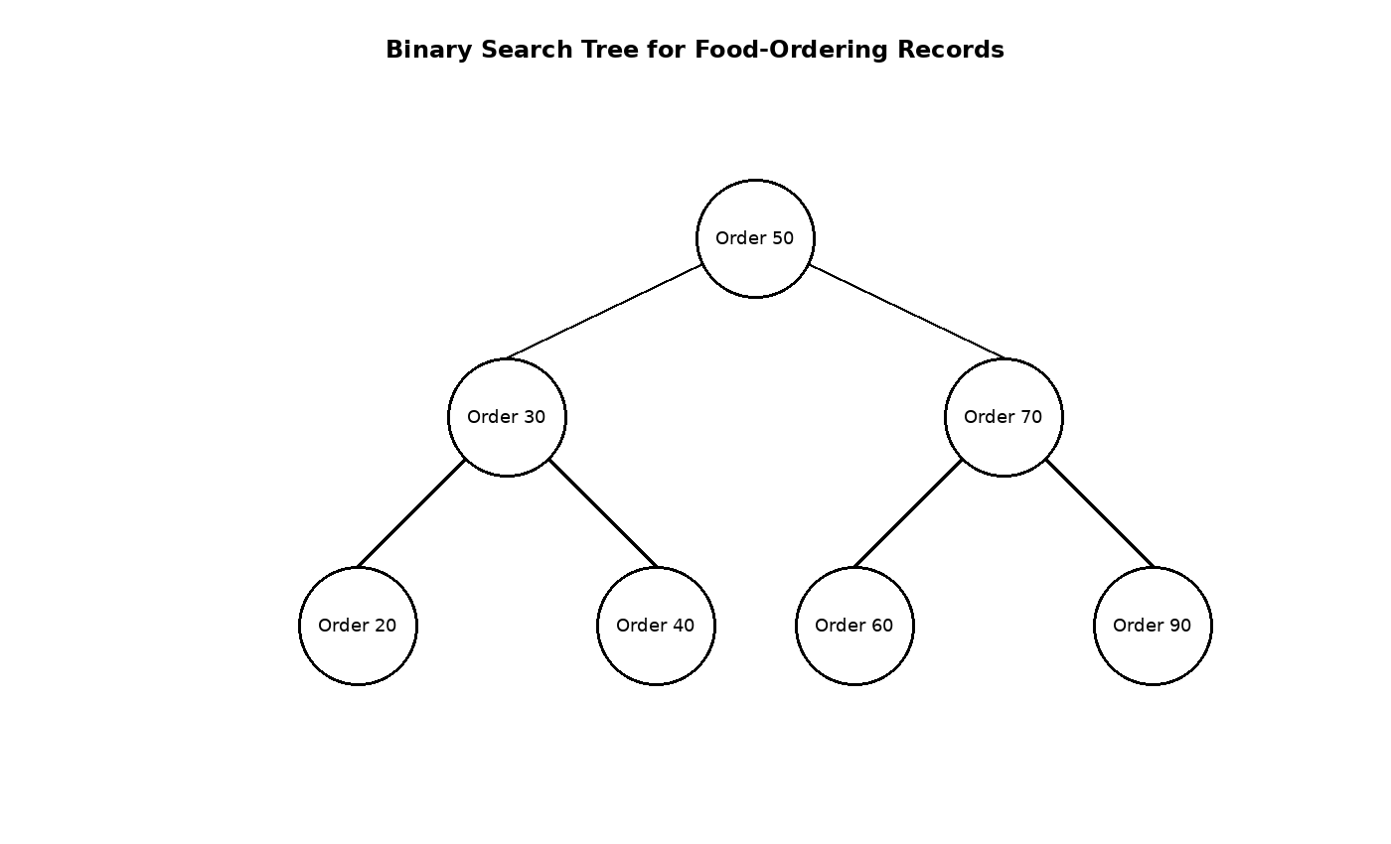
Illustrative project diagram based on the system design; replace with your actual implementation screenshot if required by your department.
Figure 5. Food Search and Filtering Flow
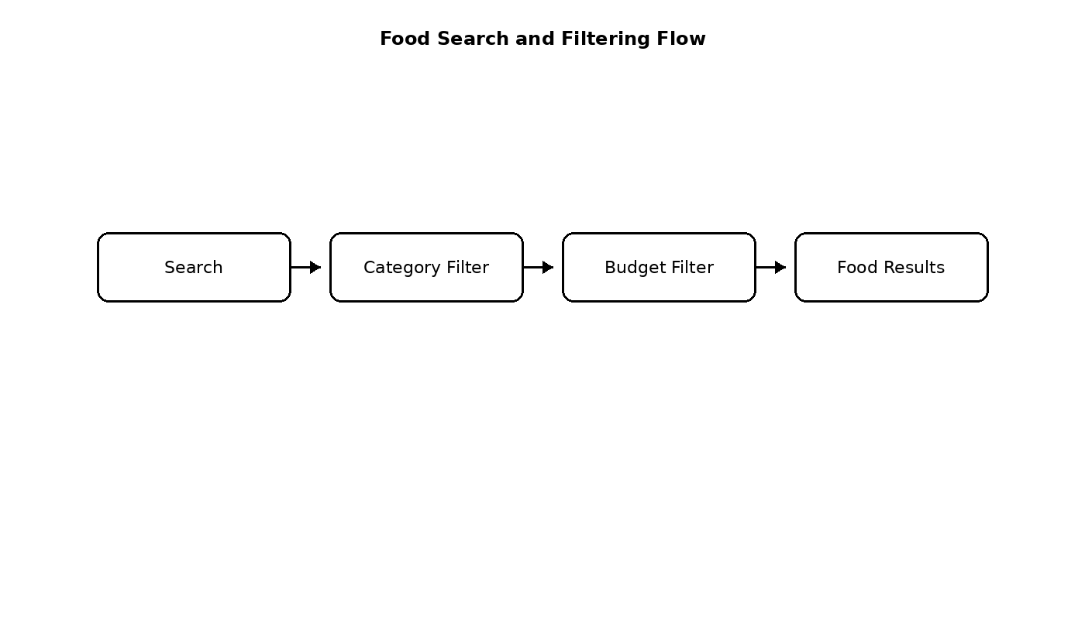
Figure 6. Cart and Order Placement Flow
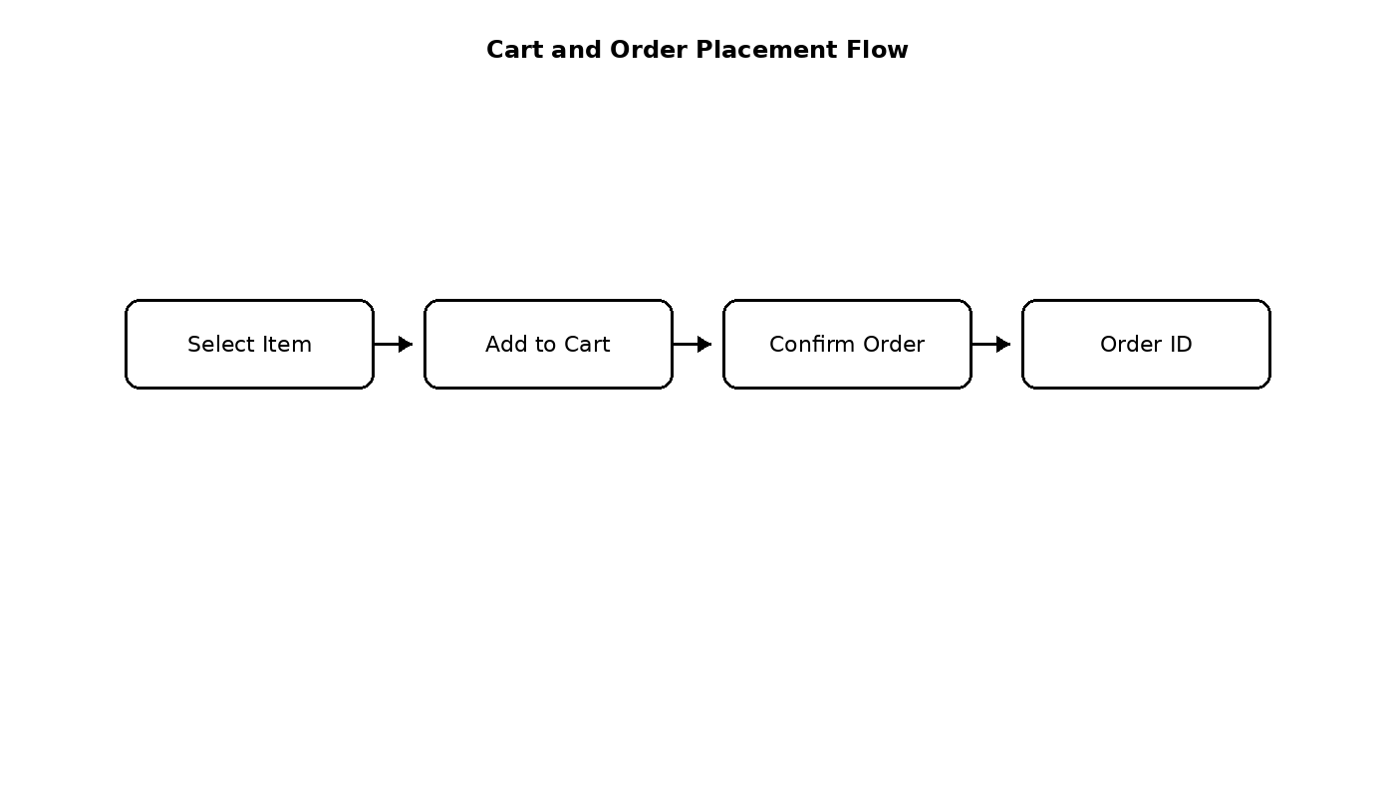
Figure 7. Food Recommendation Module
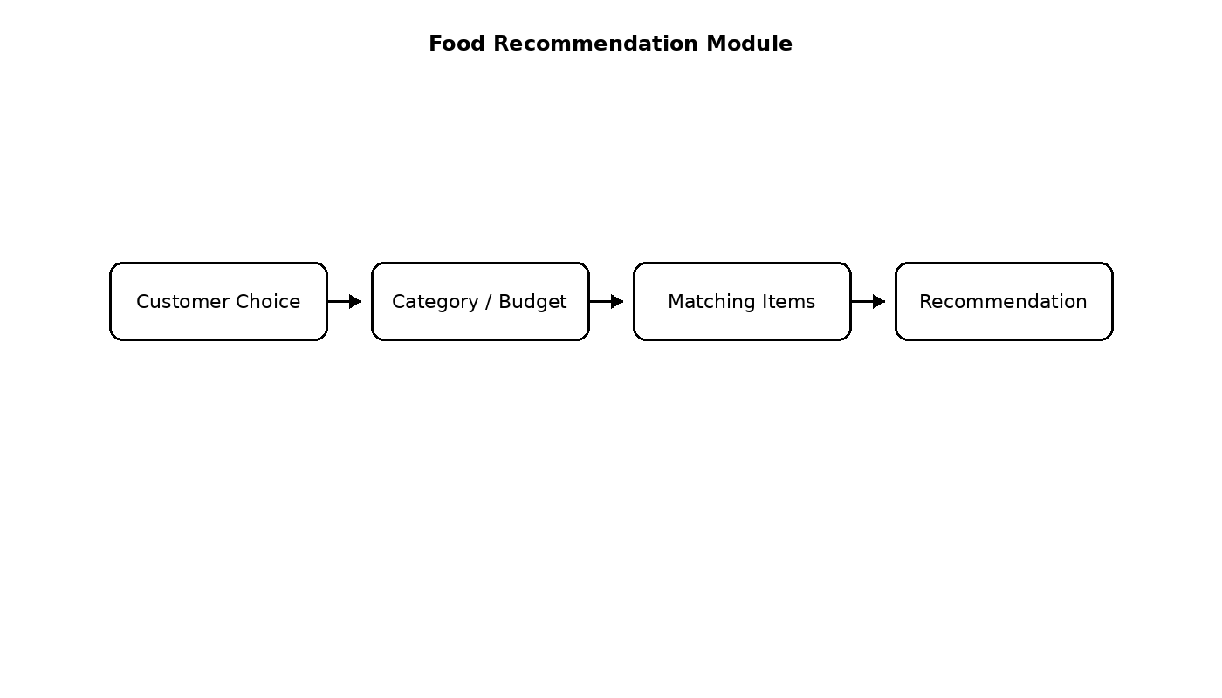
Figure 8. Order Tracking and Status Flow
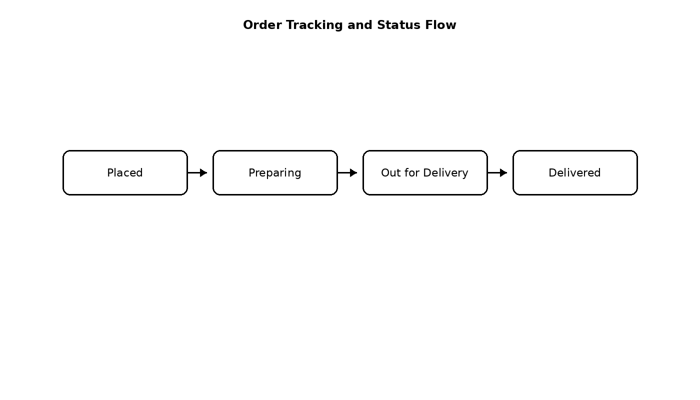
Figure 9. Three-Member Module Responsibility
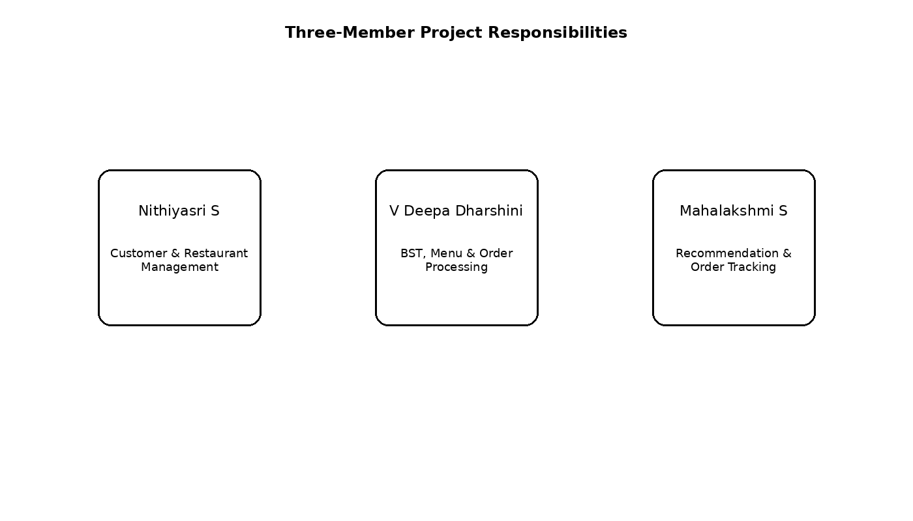
Illustrative project diagram based on the system design; replace with your actual implementation screenshot if required by your department.
Figure 10. System Testing and Evaluation Flow
